

**GAP ANALYSIS DOCUMENT (GAD) SIGN-OFF**

**Authorization Memorandum**

This form is to sign-off completion of the Requirement Phase for **CAMPUS MANAGEMENT SOFTWARE AT WORLD SKILL CENTER (WSC).**

World Skill Centre (WSC) acknowledges receipt of the deliverables as part of the Requirement Phase through the submission of this document.

|  |  |
| --- | --- |
| **MODULE NAME** | **Payroll Module** |

| **VERSION HISTORY** | | | |
| --- | --- | --- | --- |
| **Version** | **Author** | **Date** | **Changes** |
|  |  |  |  |
|  |  |  |  |

**WSC AUTHORITY NAME AND**  **SIGNATURE**

**SOUL AUTHORITY NAME AND**  **SIGNATURE**

Pages 1 of 14



**GAP Analysis Document**

Of

**Payroll module**

For Implementation of

**Campus Management Software**

at

**World Skill Center (WSC)**



**Sustainable Outreach And Universal**

**Leadership (SOUL) Limited**

**Contents**

A. Introduction 3

B. Overview of the Document 3

C. List of Screens 4

D. Payroll Workflow 5

E. Employee Tax Exemption Workflow 6

F. Employee Expense Claim & Employee Advance Workflow 7

G. Additional Salary & Incentives Workflow 8

H. Screen-wise Gap 9

1. Masters 9

1.1 Salary Component 9

1.2 Salary Structure 9

1.3 Payroll Period 10

2. Transactional Screen 11

2.1 Payroll Entry 11

# **Introduction**

The World Skill Center (WSC) is a premier advanced skill training institute established by the Government of Odisha, Skill Development and Technical Education Department, through the Odisha Skill Development Authority (OSDA). The WSC will impart advanced skill training in eight trades from engineering and service sectors. WSC caters primarily to induct the best talent from ITIs and Polytechnics and train them to become globally employable in emerging areas such as "Industry 4.0". WSC is housed in a state-of-the-art, 18-storey, air-conditioned building with nearly half a million square feet of space in the heart of capital city of Bhubaneswar.

With the Implementation of campus management software for WSC the goal is to streamline the operations and functions of the campus by integrating various processes, such as admissions, course registration, academic progress tracking, and financial management, HRMS, Procurement and Inventory management, etc into a unified system. The implementation also aims at providing a user-friendly interface for all stakeholders, making it easier for them to access the necessary information and complete their tasks with ease. The modules to be covered during the implementation of the software includes:

|  |  |
| --- | --- |
| Students Management Modules | Infrastructure Management |
| Academic System | Finance and Accounting System |
| Procurement & Inventory Management | Training and Placement |
| Human Resources Management System | Application Integration |

# **Overview of the Document**

The Gap analysis document is a detailed report that provides an overview of the

gaps between the current state of the project and the desired state, and develop recommendations to close those gaps. Conducting a gap analysis can help us to improve our product and profitability by allowing us to pinpoint “gaps” present in our software. Once it’s complete, we will be able to better focus on our resources and energy on those identified areas in order to improve them.

This document covers all the gaps between the existing software and functional requirements provided by WSC SME’s for Payroll module.

# **List of Screens**

The table below is list of screens present for the Payroll module. Yes in Change in Existing column means that there will be change for a existing screen in the Campus management software, while Is new screen means the screen is not present in the existing software and will be newly developed. This document contains list of changes in existing screens, while requirements for new screens are covered in the SRS document.

|  |  |  |  |
| --- | --- | --- | --- |
| **SL no** | **Name of the Screens** | **Changes in Existing** | **Is New Screen ?** |
|  | Payroll Period | Yes | No |
|  | Income Tax Slab | No | No |
|  | Salary Component | Yes | No |
|  | Salary Structure | Yes | No |
|  | Employee | No | No |
|  | Payroll Settings | No | No |
|  | Salary Structure Assignment | No | No |
|  | Salary Slip | No | No |
|  | Payroll Entry | Yes | No |
|  | Expense Claim Type | No | No |
|  | Expense Claim | No | No |
|  | Employee Advance | No | No |
|  | Journal Entry | No | No |
|  | Payment Entry | No | No |
|  | Employee Other Income | No | No |
|  | Employee Tax Exemption Sub Category | No | No |
|  | Employee Tax Exemption Category | No | No |
|  | Employee Tax Exemption Declaration | No | No |
|  | Employee Tax Exemption Proof Submission | No | No |
|  | Additional Salary | No | No |
|  | Retention Bonus | No | No |
|  | Employee Incentive | No | No |
|  | Employee Benefit Application | No | No |
|  | Employee Benefit Claim | No | No |

# **Payroll Workflow**

**Existing Payroll Process Flow**

# **Payroll Existing Workflow.drawio**

**WSC Payroll Process Flow**

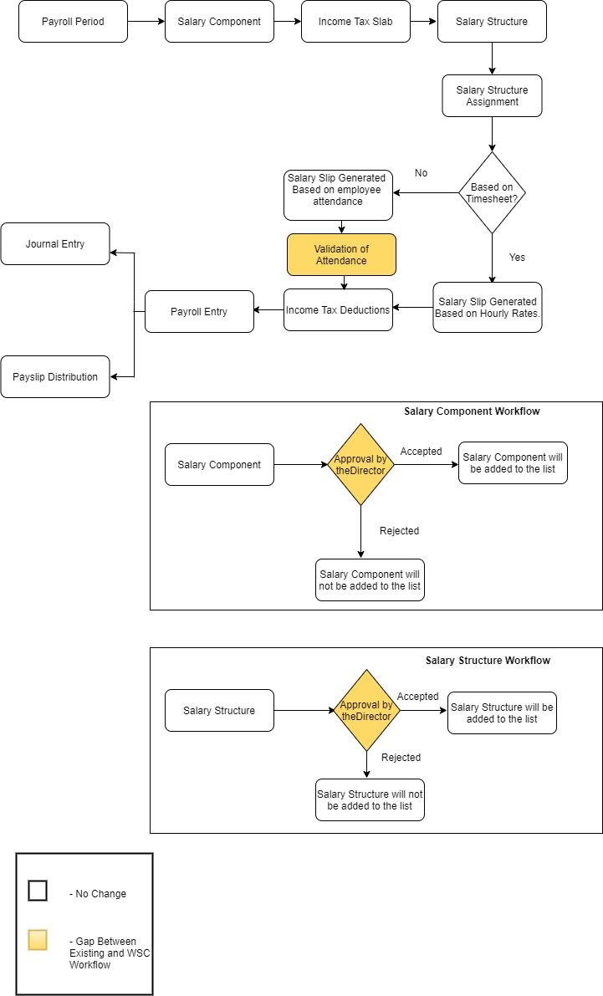

# **Employee Tax Exemption Workflow**

**Existing Employee Tax Exemption Process Flow**

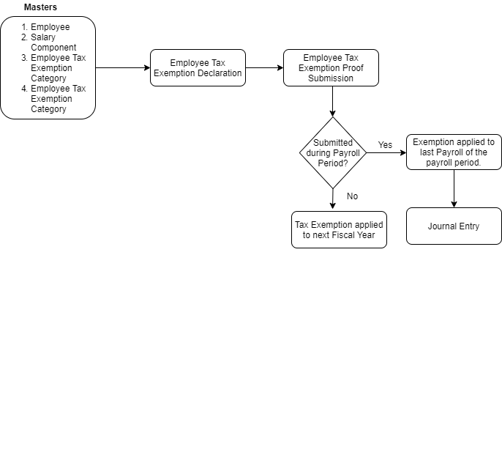

**WSC Employee Tax Exemption Process Flow**

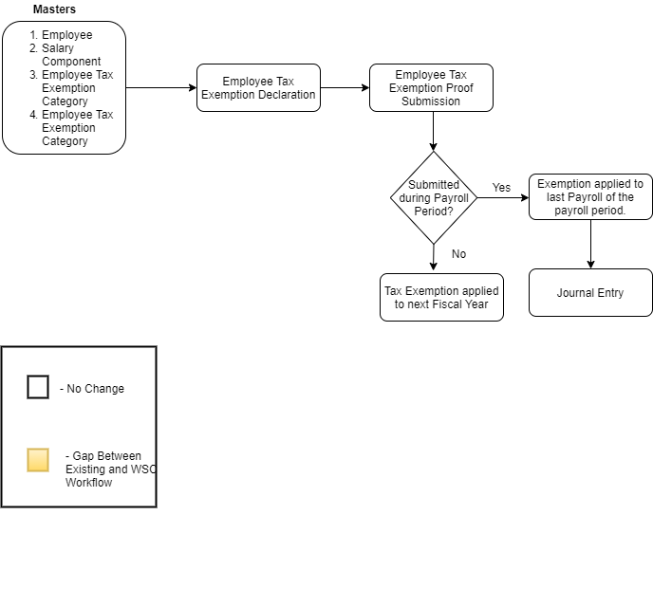

# **Employee Expense Claim & Employee Advance Workflow**

**Existing Employee Expense Claim & Employee Advance Process Flow**

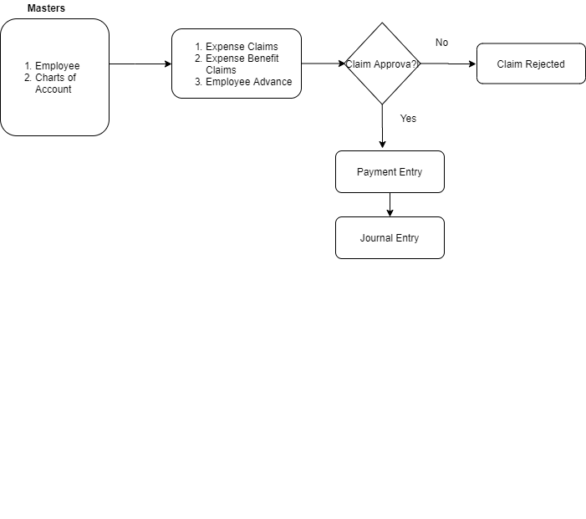

**WSC Employee Expense Claim & Employee Advance Process Flow**

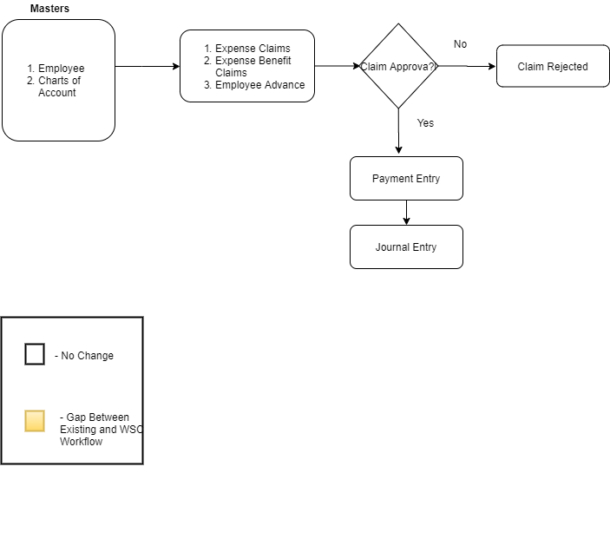

# **Additional Salary & Incentives Workflow**

**Existing Additional Salary & Incentives Workflow Process Flow**

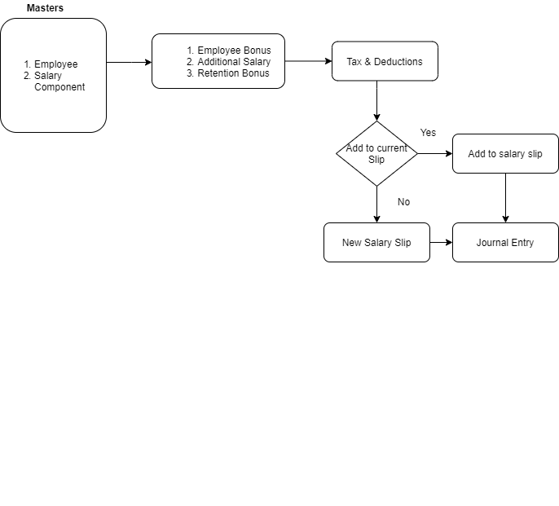

**WSC Additional Salary & Incentives Workflow Process Flow**

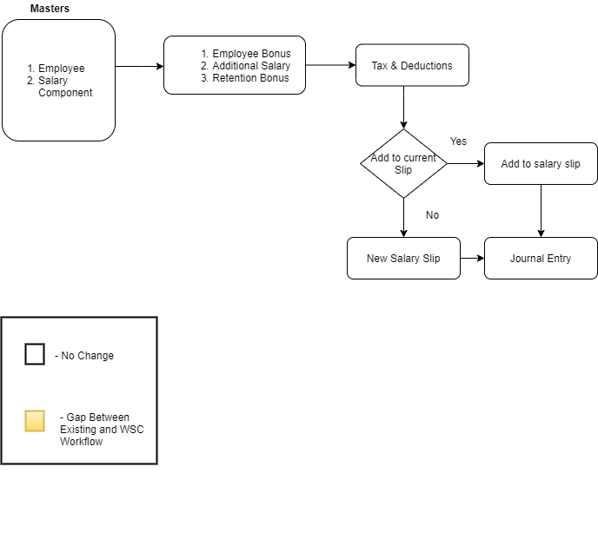

# **Screen-wise Gap**

## **Masters**

### **Salary Component**

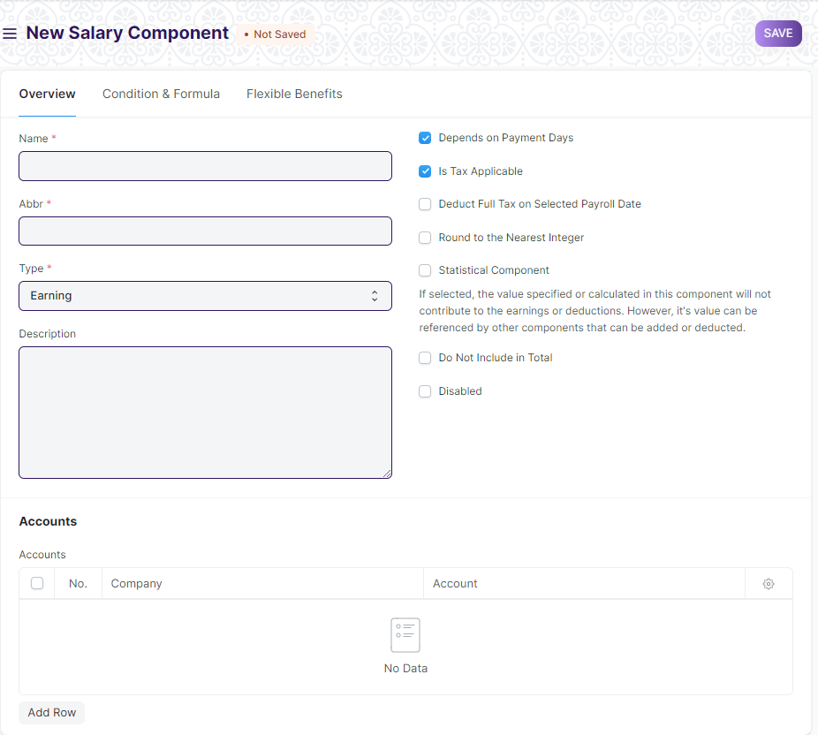

**Description of Changes:**

* A salary component needs to be approved by an admin before its submission and further use in the payroll
* A “**workflow**” need to be added for the same

### **Salary Structure**

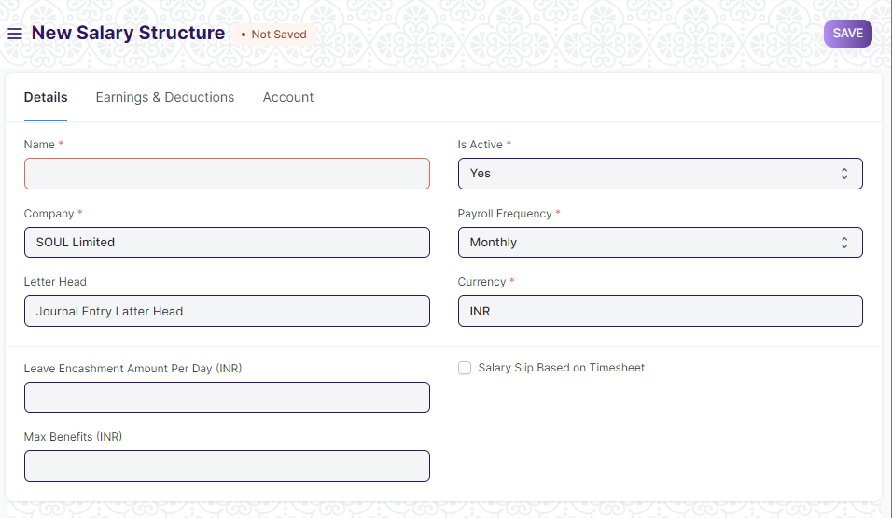

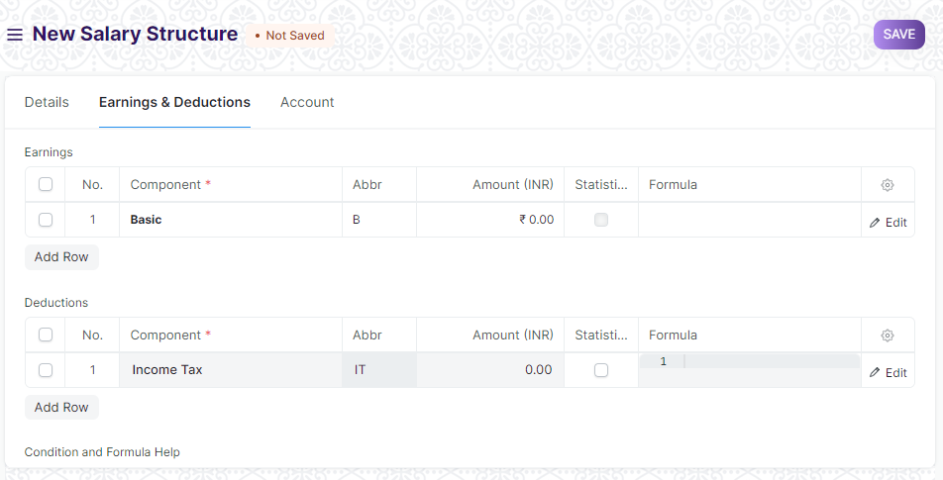

**Description of Changes:**

* A salary structure needs to be approved by an admin before its submission and further use in the payroll.
* A “**workflow**” need to be added for the same.

### **Payroll Period**

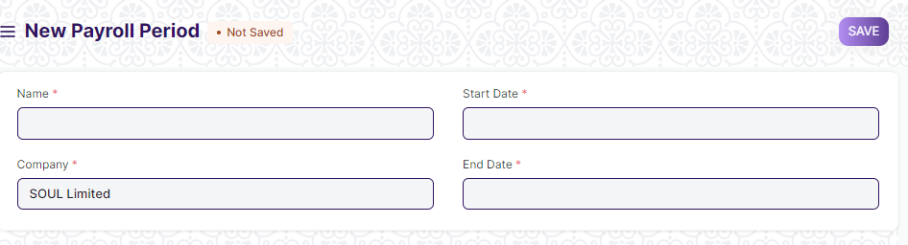

**Description of Changes:**

* “**Attach**” button need to be added.Attach button will be made mandatory after Go live.

## **Transactional Screen**

### **Payroll Entry**

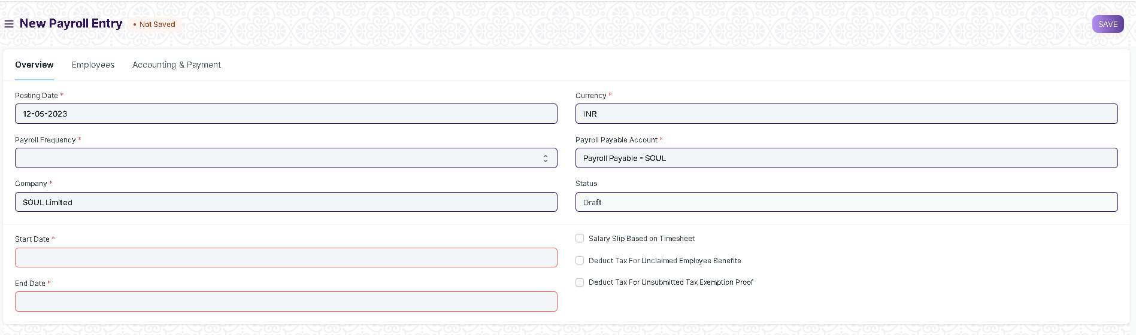

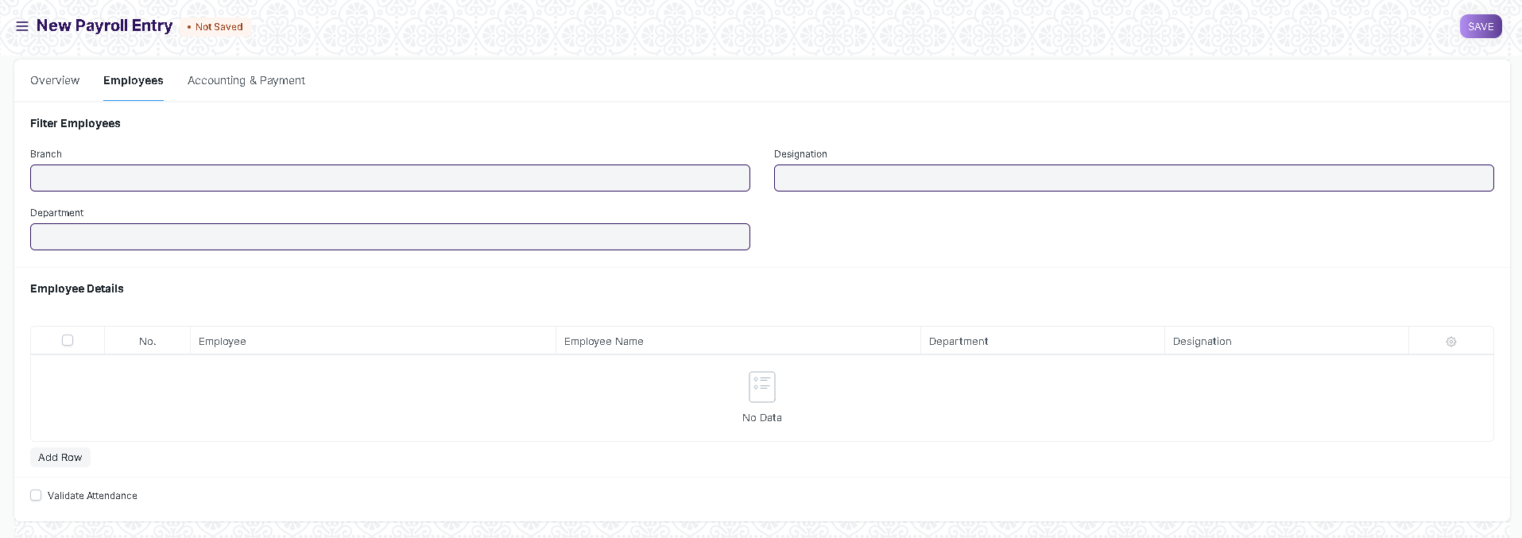

**Description of Changes:**

* Need to add an attach button in payroll entry for the validation of Employee’s Attendance before generating salary slips.